- Purpose
  - The purpose of this document is to describe the procedure for machining the squeegee bumper wheels.
- Scope
  - This SOP applies to all equipment assembly team members. The process applies to the following machine ID’s:
EP50285EQS0600BE1200 – 30” Squeegee Assembly
EP50330EQS0600BE1200 – 35” Squeegee Assembly
EP50331EQS0600BE1200 – 40” Squeegee Assembly
EP50332EQS0600BE1200 – 45” Squeegee Assembly
- Responsibilities
  - The operations manager/supervisor is responsible for enforcing this SOP.
- Materials
  - The proper materials needed for this process are listed on the machine work order.
  - Drill Press with bit
- Definitions

- Procedure
  - Clamp a wheel (E28509) into the vise that is with the drill press. Make sure the wheel is sitting on the flat surface of the vise so that the center bearing (white sleeve) does not push out the back.
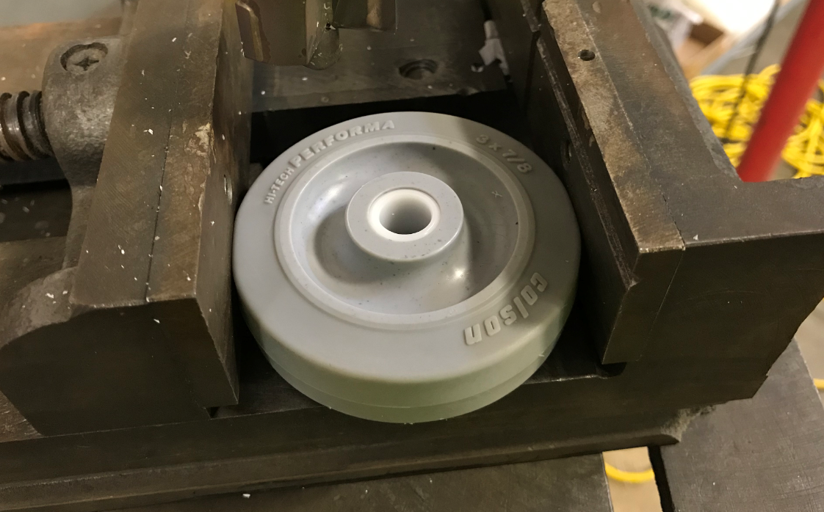

  - Center the wheel up with the drill bit. The bit has a pilot to help do this. Hold the vise tightly and machine off of the material from the wheel until it is flush with the lower surface of the inner wheel. Use light pressure on the press so that it doesn’t kick. Set the depth on the press.
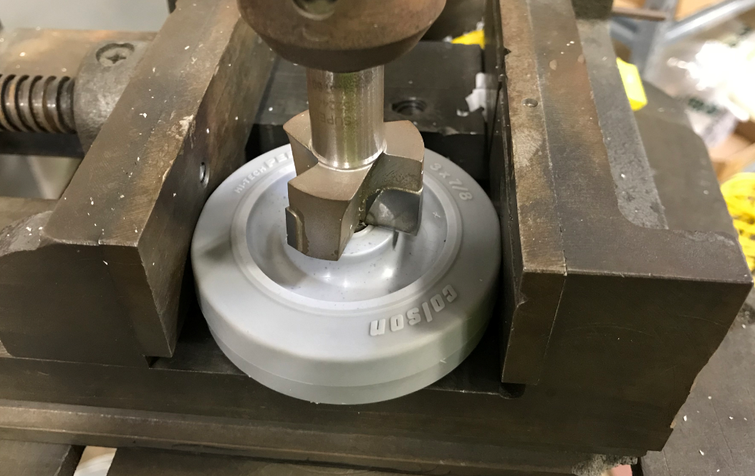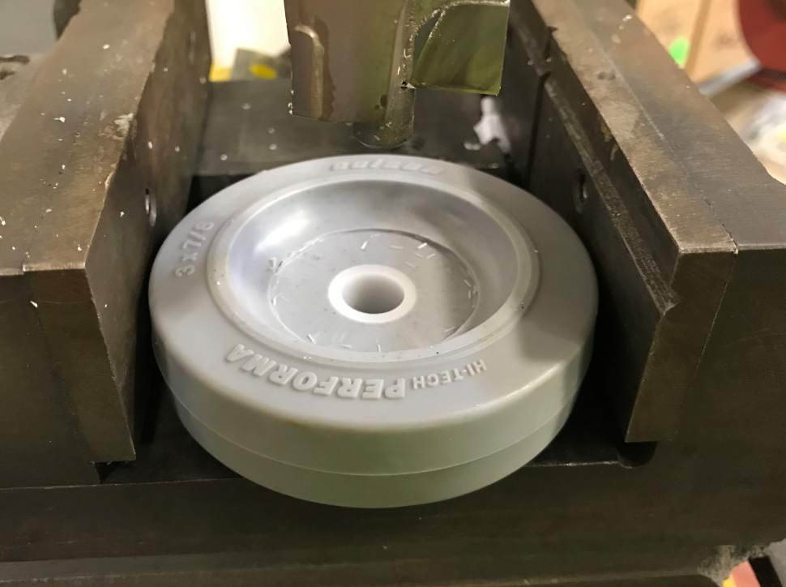
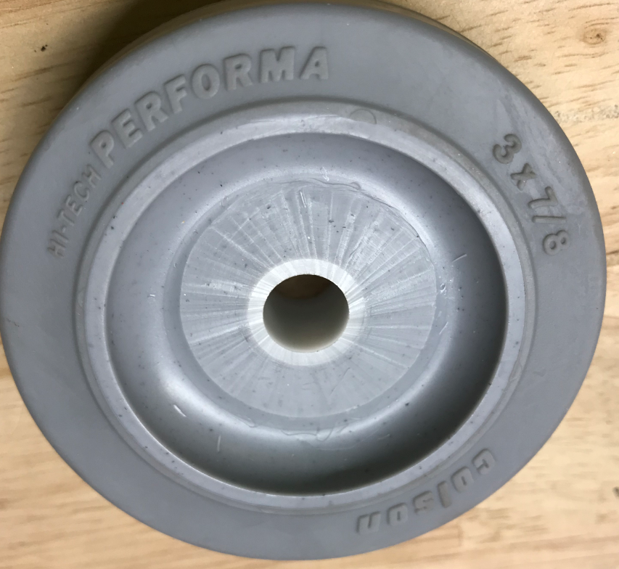
Cut so the machined surface matches the existing surface
  - Continue for the required number of wheels.

- References (optional section as needed)

- Training Guide

Functional Training Groups Requiring Training
Equipment Assembly Group

- SOP Change Control

Date of Change | Reason for Change
Rev 01 | This is the first version of the S.O.P. hence there are no revisions to this document.
Rev 02 - 4/2/2025 | Combined the MSAS and G20 instructions

Approvals

Submitter/Author Approval:__________________________________ Date:______________________

Management Approval:______________________________________ Date:______________________

QAU Approval:_____________________________________________ Date:______________________

